***Data Analytics***

**Case Study: Analyzing sales data of company.**

1. Build a Bar Chart to show "Sum of Sales by Years in West Region" by using Filters.

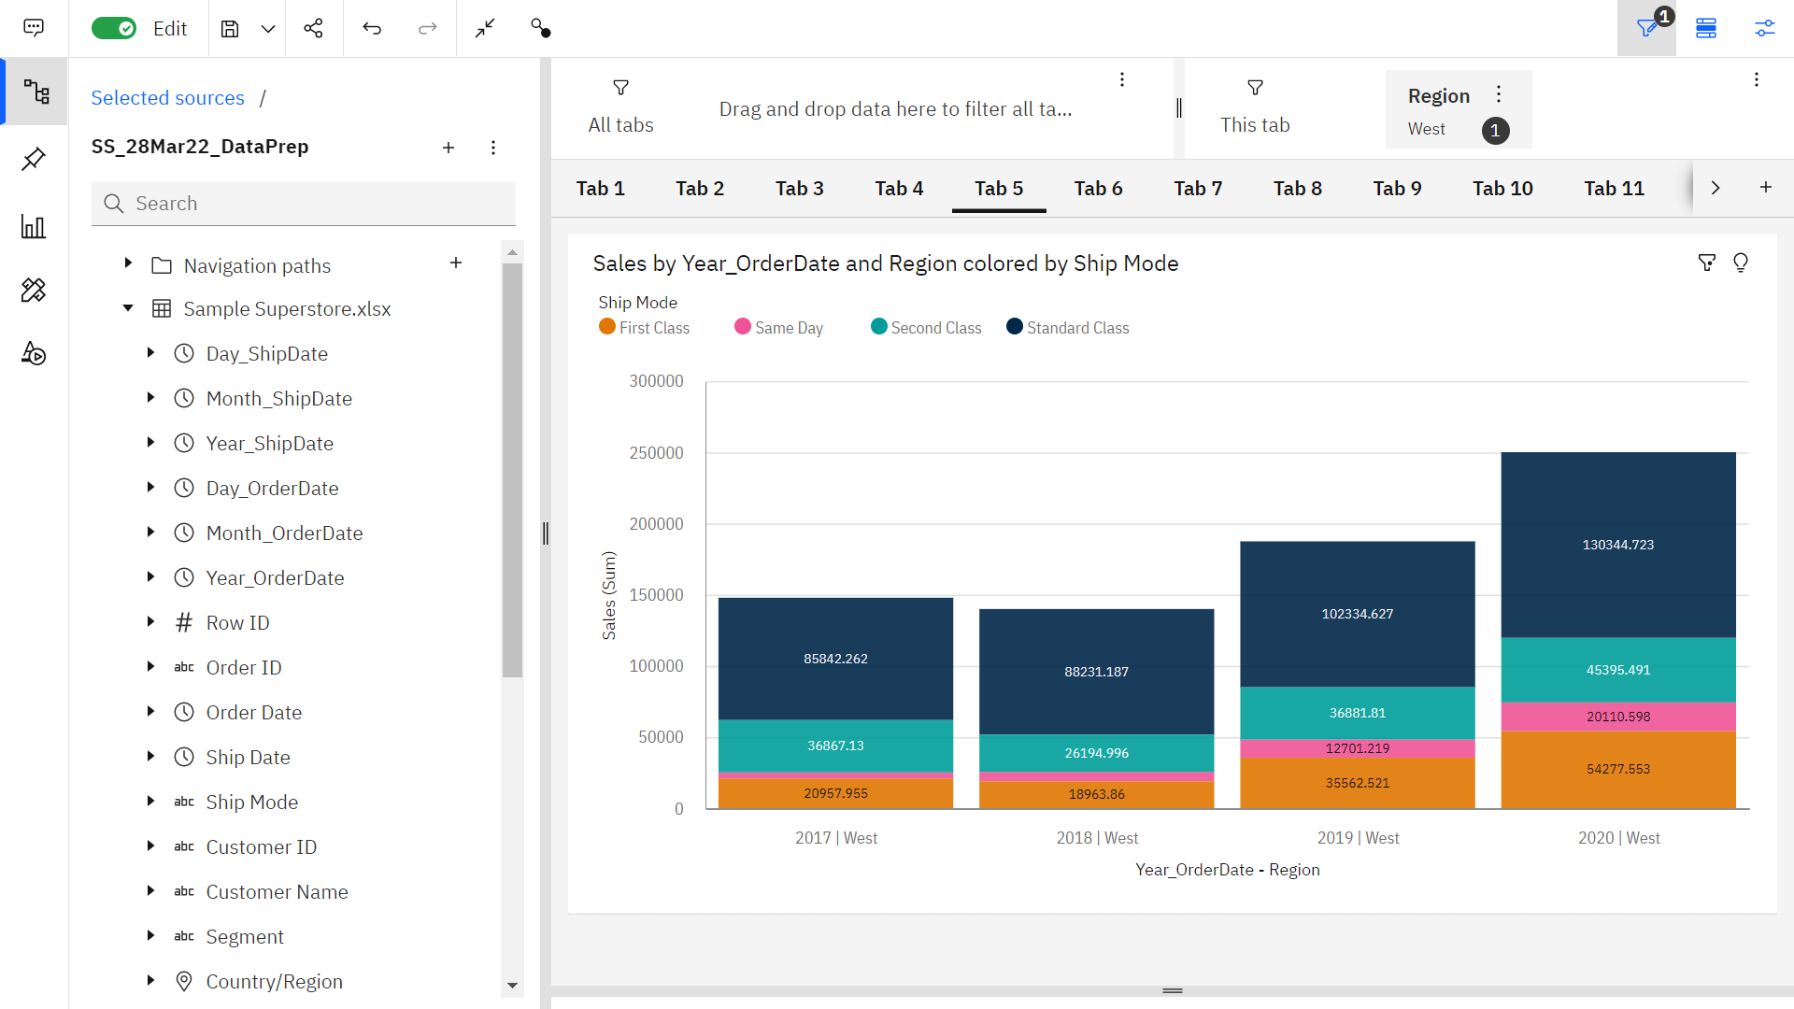

1. Build a Text table to show "Region wise, Category-wise Yearly Sales with Totals.

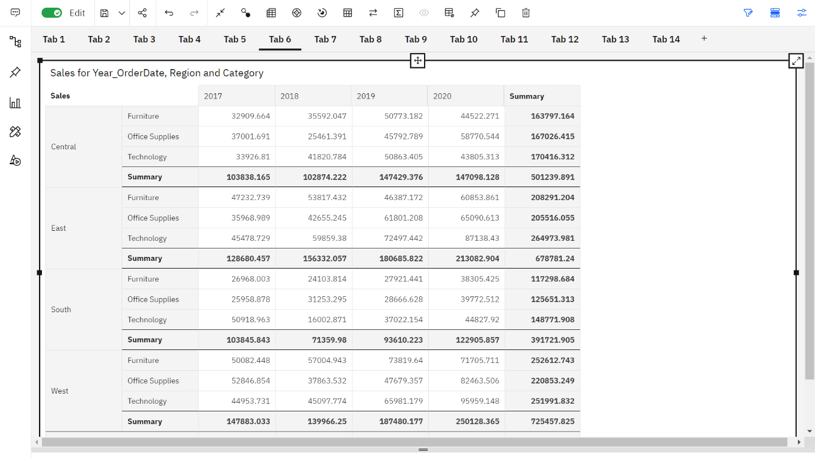

1. Build a Line Chart to show the Forecast of Monthly Sales and Profits.

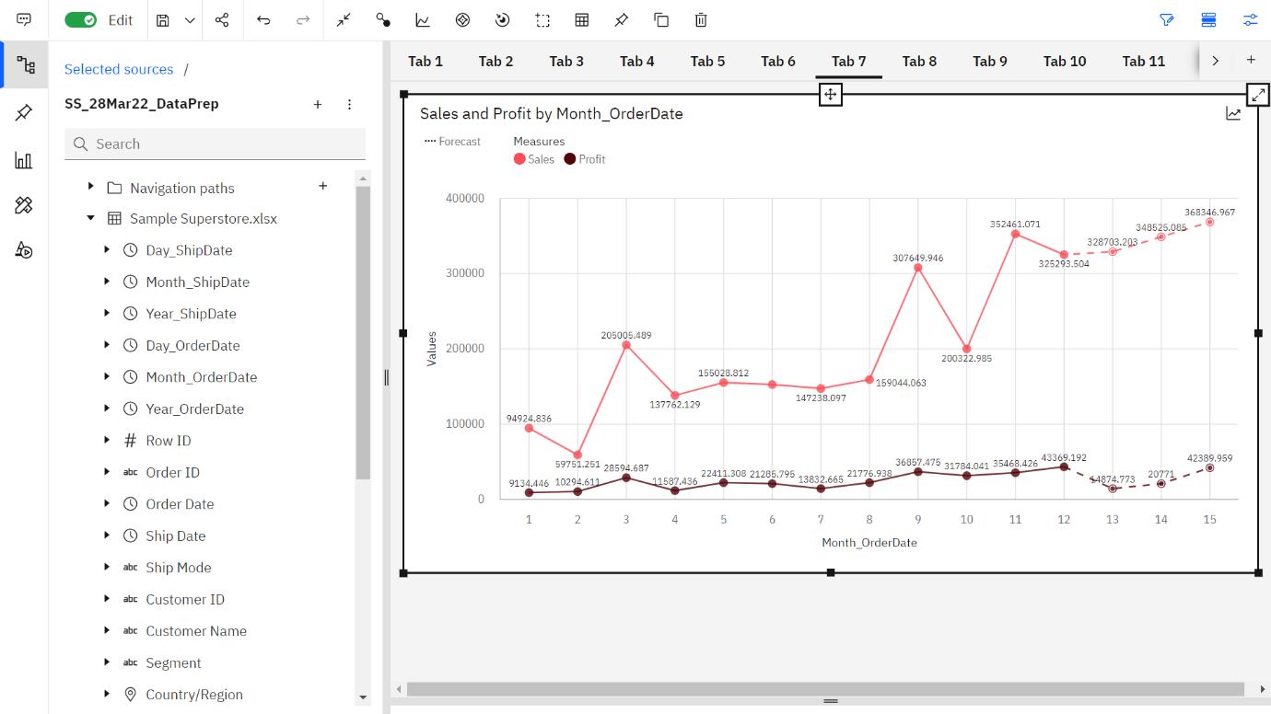

1. Build a Scatter Plot to show the Trends of Sales vs Profits.

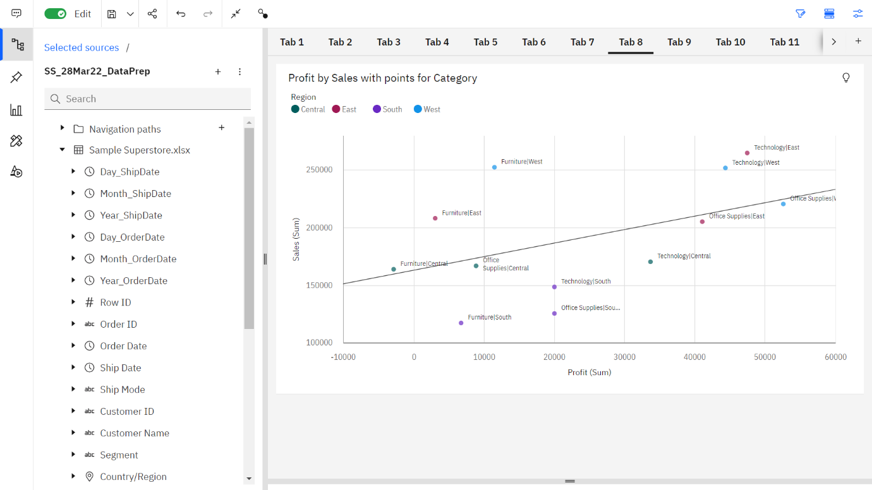

1. Build a Heat Map to show the yearly Sales and Profit by Region and Category.

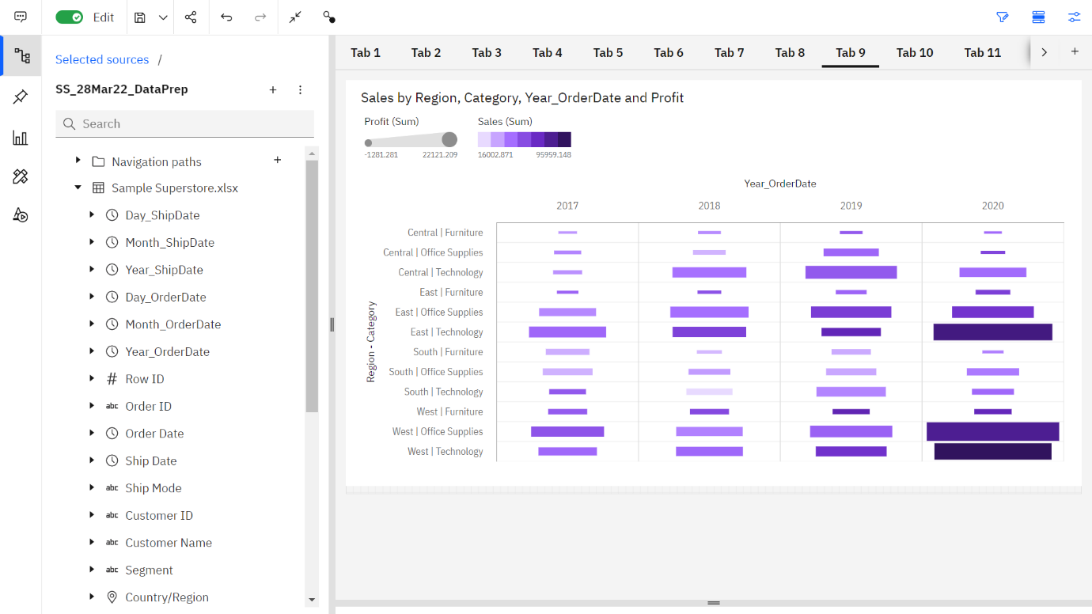

1. Build a Waterfall Chart of Sales by Sub-Category.

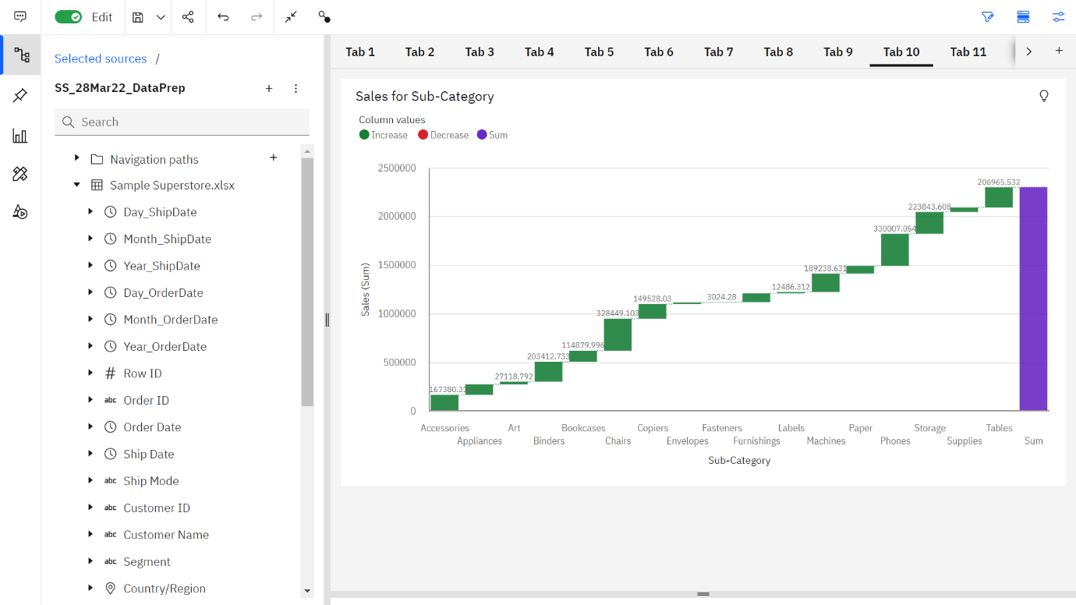

1. Build a Tree map to show Sub-Category wise Sales and Profits.

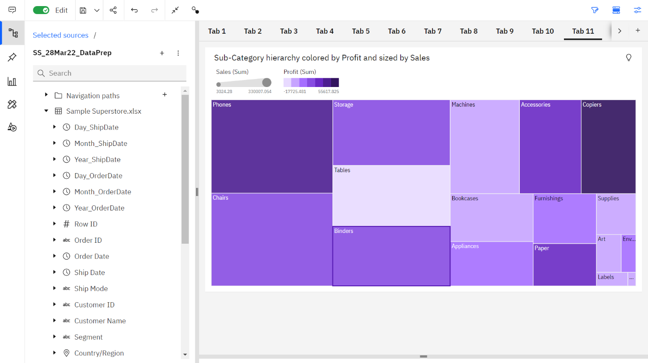

1. Build a Pie Chart of Sales by Sub-Category.

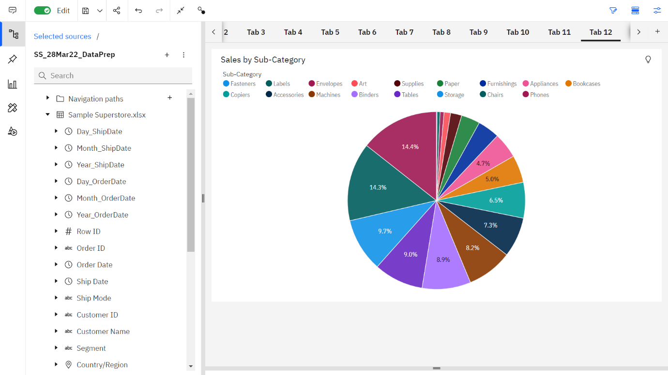

1. Build a Map visual of Region and Sales for State points.

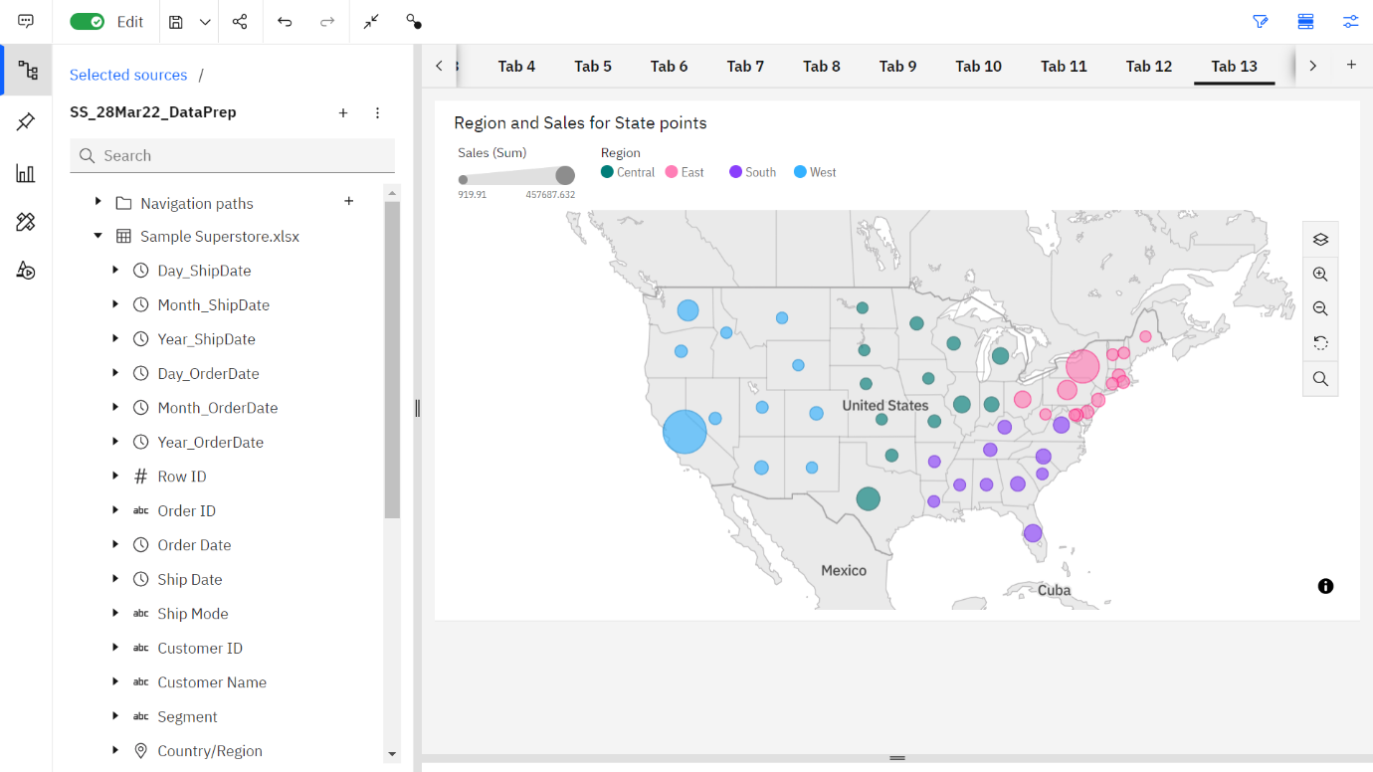

1. Build a Word Cloud Visual showing the Sales vs Profits of States by Segment Colours.

